Northern Small Circle
# Source: AI Source: Provided by: [Data Path: Persons Table -> ID Column: 1, Name_En Column: Motasem Essam] -> From: [ChatGPT] on [7/25/2026]
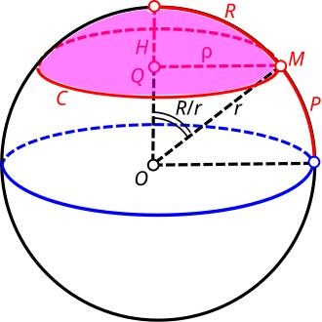

Definition
# Source: AI Source: Provided by: [Data Path: Persons Table -> ID Column: 1, Name_En Column: Motasem Essam] -> From: [ChatGPT] on [7/25/2026]
A northern small circle is a small circle on a sphere located north of a chosen equatorial plane or reference great circle. It is formed where a plane parallel to the equatorial plane, but not passing through the sphere’s center, intersects the sphere.
On Earth, a circle of latitude north of the Equator—such as the Tropic of Cancer or the Arctic Circle—is an example of a northern small circle.
Important distinction: “Northern” identifies the circle’s position relative to a chosen orientation. It does not describe a different mathematical kind of circle.

Simple Definition
# Source: AI Source: Provided by: [Data Path: Persons Table -> ID Column: 1, Name_En Column: Motasem Essam] -> From: [ChatGPT] on [7/25/2026]
A northern small circle is a circular line around the northern part of a sphere, parallel to its equator and smaller than the equator.

Geometric Structure
# Source: AI Source: Provided by: [Data Path: Persons Table -> ID Column: 1, Name_En Column: Motasem Essam] -> From: [ChatGPT] on [7/25/2026]
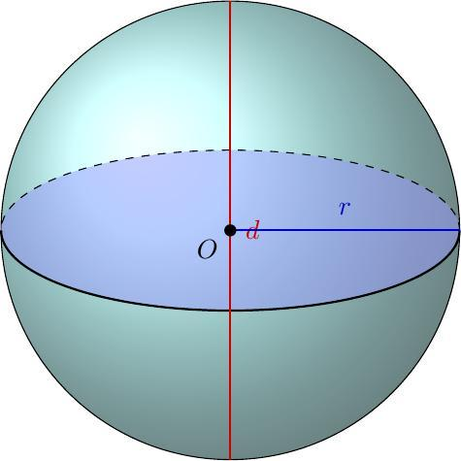
The main geometric elements are:
- Sphere center $O$: The center of the sphere.
- Equatorial plane: The reference plane passing through the center.
- Northern small-circle plane: A plane parallel to the equatorial plane, positioned north of it.
- Small-circle center $C$: The point where the sphere’s central axis intersects the small-circle plane.
- Sphere radius $R$: The distance from the sphere center to any point on the sphere.
- Small-circle radius $r$: The distance from $C$ to any point on the small circle.
- Northern latitude $φ$: The angular latitude measured northward from the equator.
- Offset $d$: The perpendicular distance from the sphere center to the small-circle plane.

Mathematical Representation
# Source: AI Source: Provided by: [Data Path: Persons Table -> ID Column: 1, Name_En Column: Motasem Essam] -> From: [ChatGPT] on [7/25/2026]
Assume a sphere centered at the origin with radius $R$, and let the positive $z$-axis point north.
Sphere equation
$$x^{2}+y^{2}+z^{2}=R^{2}$$
Northern small-circle plane
At northern latitude $φ$, where $0^{∘}<φ<{90}^{∘}$, the plane is
$$z=R\sin{φ}$$
Substituting into the sphere equation gives
$$x^{2}+y^{2}=R^{2}\cos^{2}{φ}$$
Therefore, the small-circle radius is
$$\boxed{r=R\cos{φ}}$$
The perpendicular distance from the sphere center to the plane is
$$\boxed{d=R\sin{φ}}$$
Because the circle is north of the equator, its plane has a positive $z$-coordinate under this coordinate convention.

Important Formulas
# Source: AI Source: Provided by: [Data Path: Persons Table -> ID Column: 1, Name_En Column: Motasem Essam] -> From: [ChatGPT] on [7/25/2026]
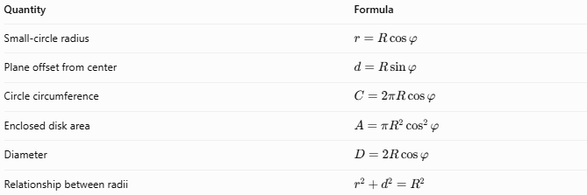
Quantity | Formula
Small-circle radius | $$r=R\cos{φ}$$
Plane offset from center | $$d=R\sin{φ}$$
Circle circumference | $$C=2πR\cos{φ}$$
Enclosed disk area | $$A=πR^{2}\cos^{2}{φ}$$
Diameter | $$D=2R\cos{φ}$$
Relationship between radii | $$r^{2}+d^{2}=R^{2}$$
Here, $R$ is the sphere radius and $φ$ is the northern latitude measured in degrees or radians, as appropriate.

Worked Example
# Source: AI Source: Provided by: [Data Path: Persons Table -> ID Column: 1, Name_En Column: Motasem Essam] -> From: [ChatGPT] on [7/25/2026]
A spherical model has a radius of $10\text{ cm}$. Find the radius and circumference of its northern small circle at latitude ${60}^{∘}\text{ N}$.
Step 1 — Calculate the small-circle radius.
$$r=R\cos{φ}$$
$$r=10{\cos{60}}^{∘}=10\left(0.5\right)$$
$$\boxed{r=5\text{ cm}}$$
Step 2 — Calculate the circumference.
$$C=2πr$$
$$C=2π\left(5\right)=10π$$
$$\boxed{C≈31.42\text{ cm}}$$
Conclusion: The northern small circle has a radius of $5\text{ cm}$ and a circumference of approximately $31.42\text{ cm}$.

Comparison with Related Circles
# Source: AI Source: Provided by: [Data Path: Persons Table -> ID Column: 1, Name_En Column: Motasem Essam] -> From: [ChatGPT] on [7/25/2026]
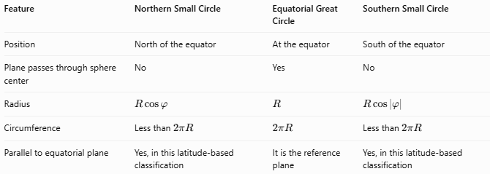
Feature | Northern Small Circle | Equatorial Great Circle | Southern Small Circle
Position | North of the equator | At the equator | South of the equator
Plane passes through sphere center | No | Yes | No
Radius | $$R\cos{φ}$$ | $$R$$ | $$R\cos\left|φ\right|$$
Circumference | Less than $2πR$ | $$2πR$$ | Less than $2πR$
Parallel to equatorial plane | Yes, in this latitude-based classification | It is the reference plane | Yes, in this latitude-based classification
For equal absolute latitudes, northern and southern small circles have equal radii and circumferences.

Examples and Applications
# Source: AI Source: Provided by: [Data Path: Persons Table -> ID Column: 1, Name_En Column: Motasem Essam] -> From: [ChatGPT] on [7/25/2026]
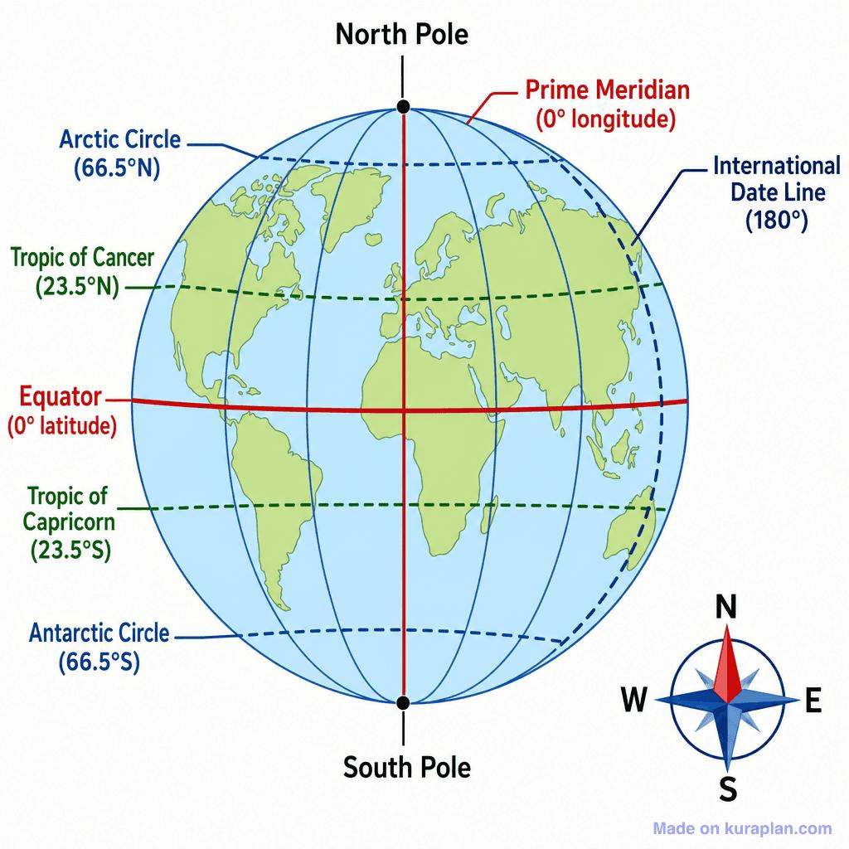
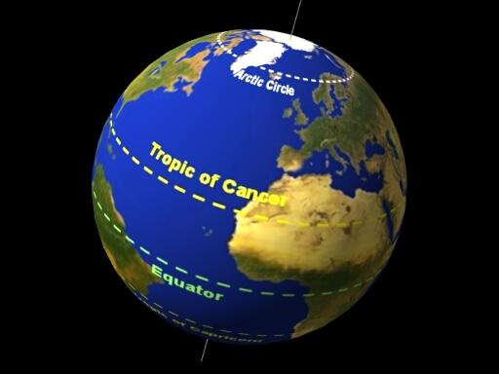
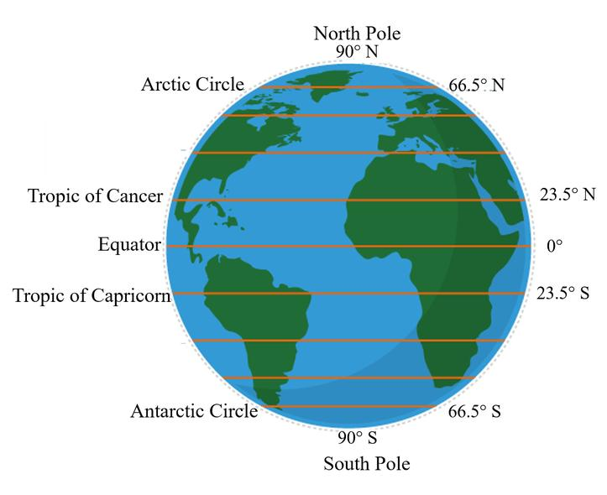
Examples of northern small circles on Earth include:
- Tropic of Cancer: Approximately ${23.44}^{∘}\text{ N}$.
- Arctic Circle: Approximately ${66.56}^{∘}\text{ N}$.
- Other northern latitudes: Any circle of latitude strictly between the Equator and the North Pole.
Applications include geographic mapping, navigation, measuring distances along a latitude, and studying the geometry of spherical cross-sections.

Key Points
# Source: AI Source: Provided by: [Data Path: Persons Table -> ID Column: 1, Name_En Column: Motasem Essam] -> From: [ChatGPT] on [7/25/2026]
- A northern small circle lies north of the equatorial plane.
- It is formed by intersecting a sphere with a plane parallel to the equatorial plane that does not pass through the center.
- Its radius is smaller than the sphere radius.
- Its radius is $r=R\cos{φ}$, where $φ$ is its northern latitude.
- Its circumference decreases as its latitude approaches ${90}^{∘}\text{ N}$.
- At the North Pole, the limiting circle shrinks to a point; it is no longer a proper circle.

Conclusion
# Source: AI Source: Provided by: [Data Path: Persons Table -> ID Column: 1, Name_En Column: Motasem Essam] -> From: [ChatGPT] on [7/25/2026]
A northern small circle is a circle of latitude or spherical cross-section positioned north of the equator. Its radius depends on the sphere’s radius and its latitude. Unlike a great circle, its plane does not pass through the sphere’s center, so its circumference is smaller than that of the equator.

